REPORT ON

Environmental Sustainability Review

For

East Side State High School

BY

JACK RUSSELL

TEACHER: MR BUSBY

SUBJECT: 10 BUSINESS STUDIES

DUE DATE: 20 May 2012

Table of Contents

1.0 SYNOPSIS 1
2.0 INTRODUCTION…..………………………………………………..2
2.1 SUBJECT OF THE REPORT 2
2.2 METHODOLOGY 2

3.0 REPORT FINDINGS 3
3.1 Environmental Sustainability 3
3.2 Environmental Hazards and Resource Efficiency Issues – current strategies/initiatives at East Side State High School 4
3.3 Strategies for Improvement 5
4.0 CONCLUSION 6
APPENDIX 8

SYNOPSIS

This report is about improving the environmental sustainability of East Side State High School. It is an audit of current practices and strategies in place around the school and recommends strategies to improve environmental performance. The report reviews current environmental hazards and a solution employed at the school and includes photos of aspects of environmental management observed during the study. This report includes a definition of environmental sustainability and its importance. Section three summaries the finding s of the report and makes recommendations for improvement. The conclusion provides a final assessment of the current position and the way to improve performance such that the school can meet the objectives of the Green Schools Initiative.
2.0 INTRODUCTION

2.1 SUBJECT OF THE REPORT

This report is about improving the environmental sustainability of East Side State High School. It is an audit of current practices and strategies in place around the school and recommends strategies to improve environmental performance. This report provides the school with the action plan to participate in the Green Schools Initiative by minimising environmental risks and by using resources and materials more efficiency in daily processes.

2.2 METHODOLOGY

The report’s recommendations are based on investigations of current environmental practices in place at the school, over a two week period. Photos of aspects of environmental management observed during the study are provided in the appendix.

To measure sustainability we measure how we use resources such as energy and water and how we use chemicals and dispose of waste materials which have the potential to pollute the environment. An audit table is included in the appendix, which documents the data gathered and identifies issues for the report.

The purpose of the report is to find the flaws in the current practices and recommend changes to enhance the outcome for the school and the environment and encourage new practices the school may not have considered.

3.0 REPORT FINDINGS

3.1 Environmental Sustainability- what is it and why is it important?

Australia's National Strategy for Ecologically Sustainable Development (1992) defines ecologically sustainable development as: 'using, conserving and enhancing the community's resources so that ecological processes, on which life depends, are maintained, and the total quality of life, now and in the future, can be increased'.

A focus on sustainability provides a chance to examine, document and measure our use of resources. Environmental problems can often be the result of inefficient practices which are wasteful. The cost of this waste is borne by the environment and organisations or business. Addressing these issues can result in cheaper practices which give a healthier environment. A win, win.

3.2 Environmental Hazards and Resource Efficiency Issues – current strategies/initiatives at East State High School

3.21 Electricity usage-

The school doesn’t have environmentally friendly light bulbs. The air-con usage is very high.

In the Home-EC faculty the ovens are high energy users.

3.22 Water usage-

Drink taps are often left on or dripping.

Toilets are not dual flush.

School oval uses recycled water for irrigation.

3.23 Littering-

There are rules for littering in place, but littering is still a serious problem in the school.

General bins only are provided around the school.

3.24 Recycling-

There is little to no recycling around the school except for a few paper recycling bins in Business faculty rooms and some industrial bins for recycling card board.

3.25 Chemicals-

There are mostly appropriate systems in place in the science and agriculture faculty for storage and disposal of chemicals.

3.26 Travel-

The school does encourage a travel smart policy, and busses and other public transport to and from school are available.

3.3 Strategies for Improvement

3.31 Electricity Usage- The school could get environmentally friendly lighting and signage to remind people to turn off the lights after each class.

3.32 Littering- Littering is one of the biggest problems around the school. There needs to be stricter rules and monitoring around littering and more bins provided around the school.

3.33 Recycling- There needs to be available recycling bins around the school for student’s everyday usage. Recycling could be put into practice a lot more all over the school, in each faculty simple things like recycling paper, printer cartridges, metal, wood and plastic recycling and other reuse of materials.

3.34 Chemicals- There is chemicals around the school that can damage the environment and harm people too. These chemicals are used by a variety of different departments eg. Manual Arts, Art, HPE, Agriculture and also the Groundsman. They need to be properly locked up and usage restricted. The presence of these chemicals around the school should be very limited. Proper disposal of chemicals in the science faculty is in place, as they provide chemical disposal bins for student use.

3.35 Wastage of Supplies- In some faculties of the school there is wastage of supplies; for example substances like paint (in the art faculty) is getting washed down the sink which is wasting paint and damaging the environment. Students are wasting materials; teachers should monitor the usage of supplies by students more closely. There is also a lot of paper wastage around the school. By simple enforcement of rules to only print when necessary and double sided printing, this could be avoided. The paper that this school orders is not recycled and recycled paper easily could be ordered in replacement.

3.36 Power Wastage- There could be a few solar panels installed around the school to offset the power wastage around the school. The usage of air-cons around the school is excessive especially in the summer months; fans and windows are available so the air-cons don’t have to be used so often. When a classroom is not being used all lights and electrical equipment should be turned off and unplugged from socket.

3.37 Water Usage- There is sometimes leaking taps that can waste a lot of water; this should be addressed as soon as the problem occurs to save water. The taps in the toilets are very prone to wasting water and they could be replaced with taps on timers that turn off automatically. If possible dual flush systems should also be installed.

4.0 CONCLUSION

The final assessment of the current position of the school is that a range of measures to reduce environmental impact are in place however the level of compliance in practice could be improved. There is not enough awareness around the importance of environmental sustainability within the school community.

There needs to be an active campaign to work positively towards getting better policies and practices in place. Over all, East State High School needs to improve student involvement in enforcing rules around littering and wastage of electricity, use of supplies and water. These small changes add up when everyone is doing it and it will minimise negative impacts on the environment.
5.0 BIBLIOGRAPHY

Environment.gov.au

Australian Sustainable Schools Initiative (AuSSI) - Areas of activity - Sustainable purchasing
Environment.gov.au (2010) Australian Sustainable Schools Initiative (AuSSI) - Areas of activity - Sustainable purchasing. [online] Available at: http://www.environment.gov.au/education/aussi/areas-of-activity/sustainable-purchasing.html [Accessed: 13 May 2012].

Environment.gov.au

Ecologically Sustainable Development home page
In-text: (Environment.gov.au, 1999)
Bibliography: Environment.gov.au (1999) Ecologically Sustainable Development home page. [online] Available at: http://www.environment.gov.au/about/esd/index.html [Accessed: 19 May 2012].

National Strategy for Ecologically Sustainable Development
Prepared by the Ecologically Sustainable Development Steering Committee
Endorsed by the Council of Australian Governments
December, 1992

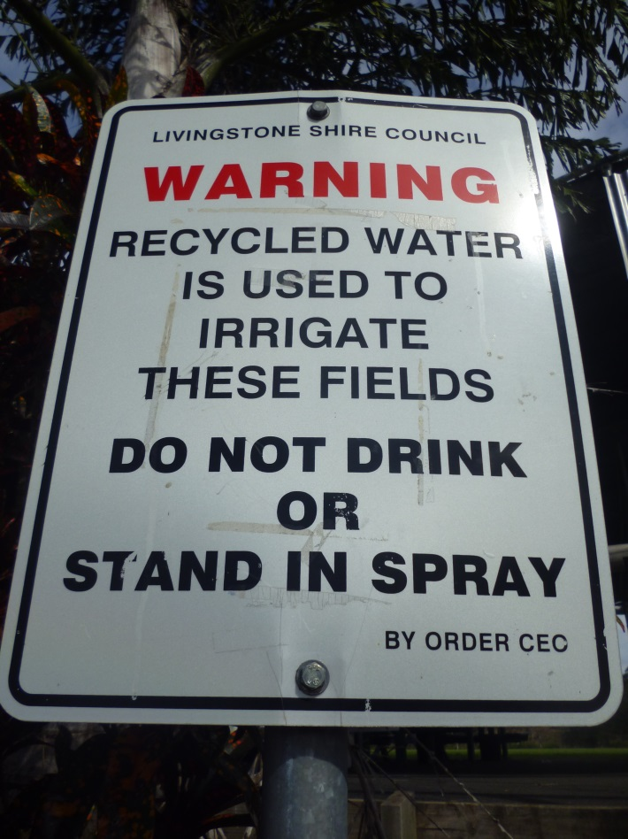
APPENDIX

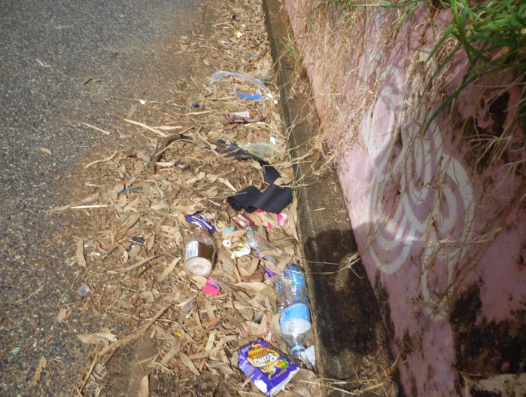
Picture 2) Litter
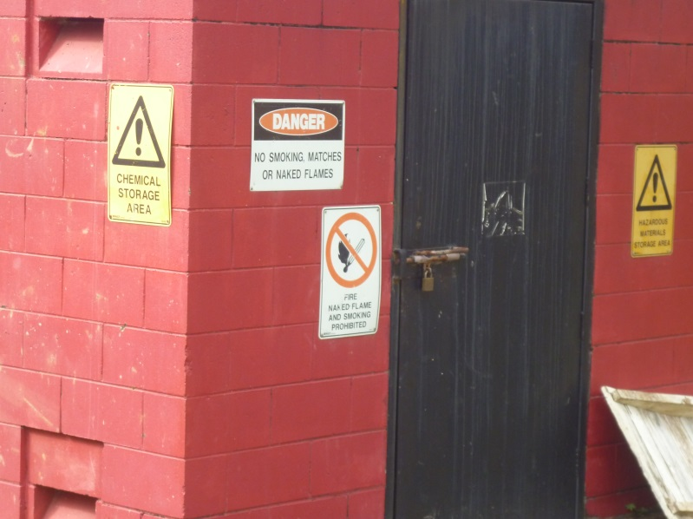

Picture 1) Oval Signage

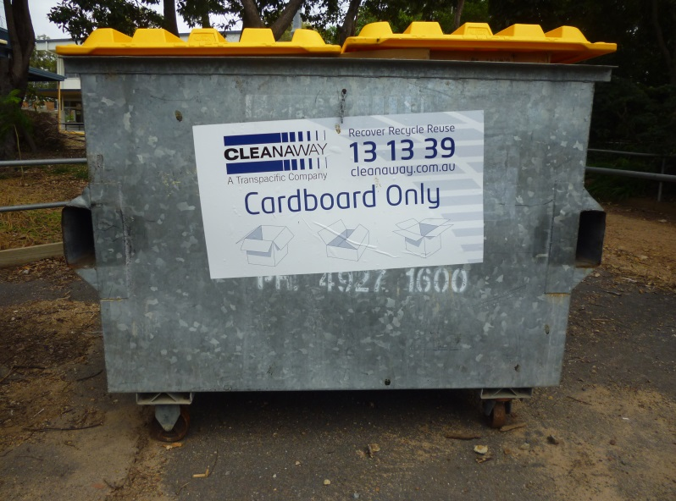
Picture 3) Agriculture Chemical Storage

Picture 4) Card Board Recycling

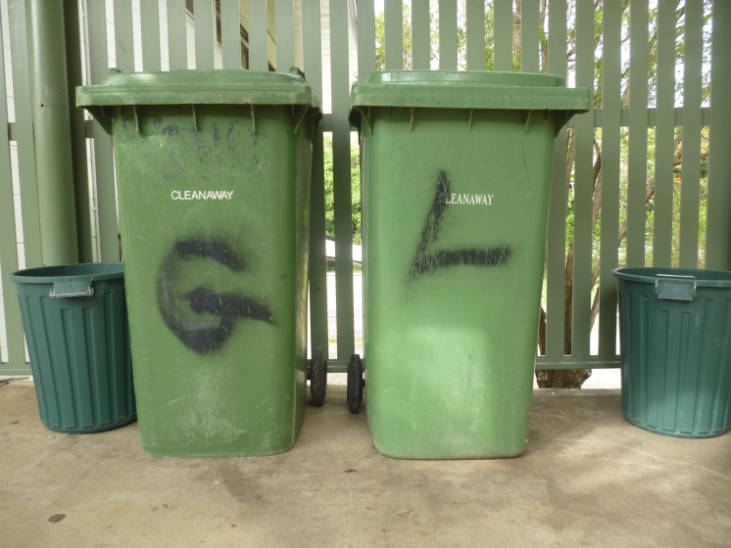

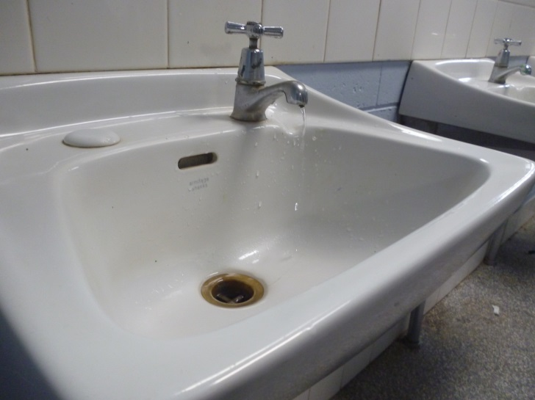

Picture 5) General Bins

Picture 6) Leaking Taps

APPENDIX – AUDIT TABLE
Faculty | Hazard (to environment and employees) | Solution | In-place? | Recommendation
Whole school | Light usage | Fluoro lights use less power.  Turn off after each lesson. |  | All classrooms to have reminder stickers next to power points.
Whole School | Recycling | recycle bins |  | Provide recycle bins around the school for students to use.
Whole School | Power usage | Solar panels |  | Use Solar panels around the school to avoid wasting electricity.
Whole school | littering | More bins |  | Provide more bins around the school, this way students will use them rather than littering.
Business Faculty | Paper usage | It should be considered |  | Students should be asked to email work if necessary instead of printing it out to hand in.
Art Faculty | Supplies | Supplies usage should be considered |  | Students are wasting materials; teachers should monitor the usage of supplies by students.
Science Faculty | Chemical storage | Signage  Qualified lab assistants  Cabinets  MSDS |  | All classrooms should have signs to indicate where to put chemical waste to ensure it doesn’t end up down the sink.
Agriculture Faculty | Hazardous Chemicals | Should be locked in shed |  | Hazardous chemical products should be stored in a locked shed and issued by a teacher.
Home Ec | Power usage | Ovens |  | Purchase energy efficient ovens to reduce power usage.
Manual Arts Faculty | Wood and metal wastage | Mulching timber off cuts  Reusing whatever possible |  | Timber off cuts should be mulched to use in the gardens around the school.

